Name:
Date:

VISUAL COMMUNICATION TOUCHSTONE 3 ASSIGNMENT QUESTIONS

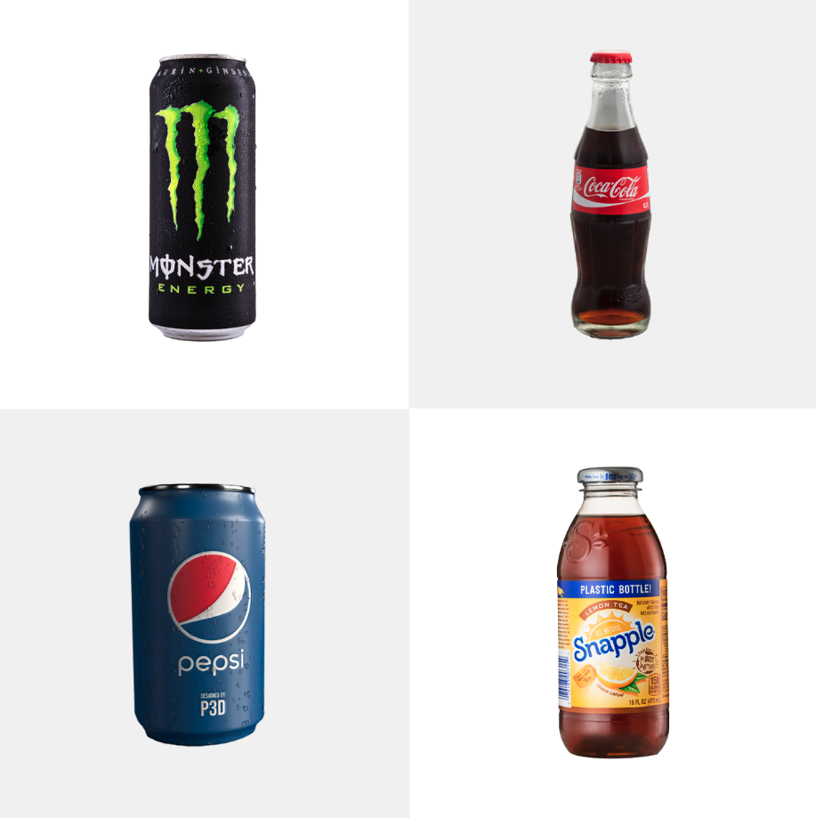
PLEASE LIST YOUR TWO CHOSEN BRANDS HERE:

1.
2.

Question 1: Basics of Visual Design Concepts

Analyze the two logos and explain how both designs employ visual communication aspects to attract consumers. Write a 200-word response that compares the logos’ use of at least two of the following: Semiotics, Visual Communication Psychology, Cognitive Theory, and or other applicable Visual Communication Theories as discussed in Unit 1.1, Vision and Interpretation. Your response must indicate your two choices from those listed above in bold and include substantive information on each. Use in-text citations if borrowing information from the course materials. No outside sources should be used.

Coca-Cola:
Coca-Cola’s logo embraces Semiotic Theory and Color Psychology. Here’s why: Semiotic Theory is the study of how signs and symbols create meaning. In visual communication, it helps explain how things like images, logos, colors, and shapes can say more than words ever could. Even if the logo is in fact just words, it’s iconic script font and vibrant red color evokes feelings of warmth, nostalgia, and happiness.

When we think of Coca-Cola, what comes to mind? Aside from adorable polar bears, you think of a classic, refreshing cola beverage that is often enjoyed as a delightful treat. Whether at a party, or paired with a meal, or something you crack open in the middle of the workday just to taste something delicious. It embodies fun, happiness and joy. And that’s all by design.

Coca-Cola also leverages color psychology. Of all the colors, why red? In color psychology, red is known to trigger emotions like energy passion, excitement, and joy. Coca-Cola’s red logo is almost always paired with messaging around friendship, family, happiness, and even Santa-Clause. So, while Semiotics explains how the colored logo becomes a recognizable symbol people recognize, color psychology explains why red makes people feel something about the brand in the first place. Together, these two theories show how Coca-Cola’s logo design isn’t just pretty scripture on a bottles, it is designed to evoke feelings and memories every time you see it.

Monster:
Monster employes a bit of both Semiotic Theory and Visual Communication Psychology with their logo design. Monster is strategic about the appearance of the “M” in their logo. Claw marked and jagged in a bright color against a start background is symbolizing intensity and strength. The monster logo can be categorized as a symbol in semiotic terms but also stands out as an index because of it’s visual ques. The jagged green “M” doesn’t literally mean “Monster”, but we’ve learned to associate with the brand and the claw marks suggest that a monster has ripped through the can. This visually points to the idea of something powerful and aggressive, like… a monster. Visual communication psychology also plays a role with Monsters logo. The logo’s bold contrast and edgy font appeals to individuals who crave intensity. There’s a reason the logo isn’t in a neutral color.

Question 2: Elements of Design

Analyze the visual elements that two of the current brand logos use in their designs, such as color schemes, shape, space, size, line, and texture. Write a 200-word response explaining how the visual elements are used in each brand design as discussed in Unit 1.2, the Elements of Design. Your response must indicate your two choices from those listed above in bold and include substantive information about each. Use in-text citations if borrowing information from the course materials. No outside sources should be used.

Both Coca-Cola and Monster logos make strategic use of color schemes and shape to communicate their brand identity. The famous Coca-Cola logo utilizes a red and white palette. The red creates a positive emotional response as discussed earlier, surrounding energy, passion, excitement, and love. While the white contrast adds simplicity and peace. Additionally, the flowing shape of the script paired with the red and white contrast gives the logo a friendly, nostalgic vibe that feels classic.

Monster takes a different approach. Using a duotone design with bold contrasts of only two colors creates a sense of energy, passion, and intensity. The “M” designed to look like a claw mark adds to the raw edgy feeling the brand is looking to evoke. The logo is visually suggesting that a monster is breaking through the can, which supports the brand’s image of being an extreme energy drink. Monster’s logo also makes great use of space to amplify it’s impact. The use of negative space draws your attention straight to the symbol, isolating it and making it feel more intense and focused. It adds to the drama!

Question 3: Principles and Elements of Visual Design

Analyze the design principles that the two brands use in their logos and how they adhere to balance, contrast, emphasis, movement, pattern, rhythm, and unity as discussed in Unit 1.3, Principles of Visual Design, and in Unit 2.1, Color. Write a 200-word minimum response explaining how at least two of those principles are applied in the logos’ designs. Your response must indicate your two choices from those listed above in bold and include substantive information about each. Use in-text citations if borrowing information from the course materials. No outside sources should be used.

A recurring theme in my responses with both logos have been their utilization of contrast to communicate their brand identities. Coco cola’s combination of red and white supports the brands emotional messaging around energy, celebration and joy. The bright red background paired with crips white letters creates high visual contrast making the logo stand out and become recognizable. The elegant script font that flows effortlessly across the logo adds to the contrast by softening the starkness of the red and balancing the visual experience. This contrast says, “look here, but don’t be alarmed.” The Coca Cola logo is also emphasized with the large, styled font that is now recognized worldwide. It’s interesting to reflect on the fact that while color is used symbolically across cultures, Coca Cola has leveraged it in a way that’s become universally symbolic of their brand.

Monster on the other hand, leads into contrast in a more aggressive way. The electric green “M” against a black background is loud and demanding. Monster also relies on emphasis with claw mark “M” symbol standing on its own with a lot of dark space surrounding it. This puts all the visual weight and focus on the mark, emphasizing the idea of intensity and energy.

Question 4: Typography, Design and Layout

Analyze the use of typography and layout practices that both brands use in their logos. Write a 200-word response that explains how they adhere to at least two of the following: type choices, alignment, layout styles, visual hierarchy, or other layout principles as discussed in Units 2.2 and 2.3, Typography and Layout. Your response must indicate your two choices from those listed in bold above and include substantive information about each. Use in-text citations if borrowing information from the course materials. No outside sources should be used.

Type plays a major rule with these two logos! The Coca Cola logo type choice is considered an old style script font. It’s flowy, elegant, and classic. Old Style type class was developed in the 1400’s and is a style that connects to tradition and nostalgia. Perfect for a brand like Coca Cola that has now been around for over a century to be associated with a script font rooted in old style traditions. Another stand out with the Coca Cola logo is the font weight. The old style type resembles the thick and thin strokes of quills that were used at the time it was developed. This appeals to the classic, nostalgic, elegant look of the Coca Cola logo. The font has a medium to heavy weight, but not in a loud way. Its thickness is bold, while still feeling smooth and soft. Another observation of Coca Cola logo is its visual hierarchy. Everything about this logo is clear and centered entirely around the brand name itself. Based on this strategic design of the large, bold, elegant text and contrasted color between red and white, the eye is drawn to the name itself. A well orchestrated design leveraging type choices and visual hierarchy that guarantees strong brand recognition.

For Monster, the type choice, weight and visual hierarchy although heavily utilized in their logo are utilized completely differently. The type choice for the Monster logo is decorative. It doesn’t neatly fit into a traditional type classification. It’s designed to stand out and set the mood for power, energy and maybe even aggression. In contrast to Coca Cola’s logo, Monster’s font is very bold and heavy in weight. Thick strokes make it bold and attention grabbing. The more narrow width of the font makes it feel sharp. This logo isn’t trying to come across friendly with the font type, weight, and width selected. It wants to come across extreme and edgy. Monster takes a modern approach to hierarchy. Instead of focusing on their name as the first thing you see, the layout of the logo leads with the symbol. The claw marked “M” dominates your attention and the actual Monster Energy” brand name is smaller and comes second. This again is a strategic way to grab a consumer attention to evoke the feeling of bold, intense energy.

Question 5: Role of Visual Design in Communication

Propose how your UX/UI team should use Ideation and Visual Thinking, Storytelling, and Inspiration as discussed in Unit 3.1, Creative Process to build a logo for Bad Apples Cider Company. Consider how the company’s name can be represented visually, and how your team could apply at least two of the concepts listed in bold above to build a logo that successfully communicates with consumers. Your 200-word response must indicate your two choices and include substantive information about each. Use in-text citations if borrowing information from the course materials. No outside sources should be used.

Designs impact moods and decision making

Emotional design is the process of creating designs intent to trigger an emotional response (pg. 2, psychology of design)

The UX/UI team should first start with an ideation session which would involve brainstorming, conceptualizing, and refining to build a creative, compelling logo for Bad Apples Cider Company. The process would start with defining what the logo should say without words. When you first hear “Bad Apples”, your mind probably goes to something negative, like bad or rotten. I’d propose the team leans into emotion design and explore ways to play with that assumption using playful or rebellious visuals. Something that evokes the same bold emotion we saw with the Monster’s branding. A design that is mischievous, edgy, and little spunky. Visual thinking helps us turn abstract ideas like “bad” or “bold” into sketches and symbols that communicate the brand’s edgy personality (Sophia Learning, Unit 3.1: Creative Process).

Once the foundation is built, the team can use storytelling to add emotion and meaning. Maybe it’s an apple that breaks the rules, or with a loud, sassy attitude. The storytelling should convey individuality with bold, crisp, flavor. The UX/UI team will combine storytelling with design to create a character and vibe that consumers feel connected to rather than just a logo.

The process of ideation, visual thinking and storytelling produces a logo that is more than just a design, it becomes a feeling. Bad Apples Cider is for people who like to live on the wild side, break rules, be sassy and sip something with a little attitude.

Question 6: Influence of Visual Design

Explain at least three ways that Bad Apples Cider Company can use Visual Design in Advertising, Public Relations, Infographics, and Publishing as discussed in Unit 3.2, the Influence of Visual Design. Keep in mind brand consistency and how other design factors like images and color play a role in visual communication. Your 200-word response must clearly indicate your three choices from those listed in bold above and include substantive information about each. Use in-text citations if borrowing information from the course materials. No outside sources should be used.

There are a few fun and creative ways Bad Apples Cider branding team can use Visual design in Advertising, Public Relations, and Infographics to build a strong consistent brand vibe.

Starting with, advertising, this brand is fun, and bold visuals are key to showing that off to consumers. I’d recommend going beyond the typical black and red often tied to “bad” or rebellious themes. Since we are trying to rebrand what “bad” means for this company. Instead, I’d lean into bright, juicy colors inspired by the different apple types themselves, such as, Granny Smith Green, Pink Lady Pink, HoneyCrisp which could be a vibrant red and orange.

And to really turn up the personality, I’d mix those vibrant colors with 70’s inspired visuals. Think groovy typeface, retro patterns, and a little bit of that free-spirited, “we make our own rules” rebellious energy. The 70’s were all about questioning the status quo, which totally fits the bad apple vibe. This mashup of rebellious and nostalgic gives the brand a unique, feel-good twist that stands out and tells a store before you even read the label.

For public relations, consistency is key. If Bad Apples is going to own this bold, retro meets rebel vibe, every touchpoint from press releases to social branding should reflect it. That means bringing in those same bright apple inspired colors and chunky 70’s fonts, playful spunky illustrations, and even psychedelic patterns. Even something as simple as a media kit should look like it was made by the coolest apple in the bunch. You want people receiving the product to feel excited and good about it. PR materials should tell the story before the words do. If we’re thinking PR boxes for social media influencers, you want something that is “Instagram worthy” and funky chunky fonts and retro vibes are on trend right now so the brand will stand out to new consumers. The goal is to make every piece of PR not just informative but fun, edgy, cool, and totally on brand.

When I think publishing, I am thinking about the posters that will go up in vendors like local liquor stores, cafes, and breweries. Most of these locations are artistic and fun and have edgy vibes. They are also where most of the targeted demographic hangs out. I’m also thinking about drink can labels, where the brand rolls right off the posters onto the can, creating a full visual experience that makes people want to hold the cool, fun, bright can. This is where bold visuals shine. Creative cider names that align with funky spunky apples, headlines that match the brands rebellious, cool, and sassy tone, and artwork that people might want to take home or snap a photo of. Most of us have had a beer can that was so pretty we didn’t want to throw it away, and that is the level of branding we want for Bad Apples Cider Company. The posters and packaging of the product shouldn’t just show the product, it should evoke a feeling within our consumer. One that not only aligns with their creative, edgy side, but one that they feel cool holding in their hand.

Publishing is just another chance to invite people into the Bad Apples World, Colorful, confident, rebellious, spunky and cool.

Image Attributions:
Coca-Cola bottle | Author: Ralf Roletschek | License: Public domain
Pepsi can | Author: Priyam Patel | License: Public domain

